JOB APPLICATION

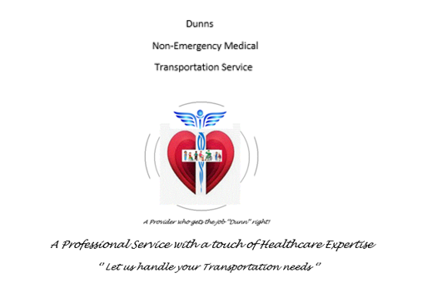

DUNNS
Non-Emergency Medical Transportation Service
P.O. Box 652
Gales Ferry, Connecticut 06335
DunnsNEMT2020@gmail.com

DUNNS Non-Emergency Medical Transportation Service is an equal opportunity employer. This application will not be used for limiting or excluding any applicant from consideration for employment on a basis prohibited by local, state, or federal law. Should an applicant need reasonable accommodation in the application process, he or she should contact a company representative.
Please fill out all sections below:

Applicant Information

Applicant Name
Home Address
City, State, Zip code
Social Security Number
Driver License Number/Type and State
Endorsements/Restrictions
Date of Birth |  | Date of Application

Employment Position

Position(s) applying for?
What days are you available for work?
What hours or shift are you available for work?
If needed, are you available to work overtime?
On what date can you start working if you are hired?
Do you have reliable transportation to and from work?
Salary desired:

Personal Information

Have you ever applied to or worked for DUNNS Non-Emergency Medical Transportation
Service before? | Yes | No
If yes, when?

Do you have any friends, relatives, or acquaintances working for DUNNS Non-
Emergency Medical Transportation Service?  If yes, state name & relationship: | Yes | No

Are you 18 years of age or older? Yes No
Are you a U.S. citizen or approved to work in the United States? |  | Yes | No
What document can you provide as proof of citizenship or legal status?

Will you consent to a mandatory controlled substance test? | Yes | No
Do you have any condition which would require job accommodations? | Yes | No
If yes, please describe accommodations required below.

Have you ever been convicted of a criminal offense (felony or misdemeanor) *? Yes No
If yes, please state the nature of the crime(s), when and where convicted and disposition of the case:

Have you ever been convicted of a motor vehicle violation? Yes No
If yes, please state the nature of the violation(s), when and where convicted and disposition of the case:

*FAILURE TO DISCLOSE ANY CRIMINAL HISTORY AND/OR MOTOR VEHICLE VIOLATION IS AN AUTOMATIC DISQUALIFICATION OF EMPLOYMENT*

Job Skills/Qualifications

Please list below the skills and qualifications you possess relative to this position for which you are applying:

(Note: DUNNS Non-Emergency Medical Transportation Service complies with the ADA and considers reasonable accommodation measures that may be necessary for eligible applicants/employees to perform essential functions. It is possible that a prospective hire may be tested on skill/agility and may be subject to a medical examination conducted by a medical professional.)

Education and Training

High School
Name | City and State | Year Graduated | Degree Earned

College/University
Name | City and State | Year Graduated | Degree Earned

Vocational School/Specialized Training
Name | City and State | Year Graduated | Degree Earned

Military

Are you a member of the Armed Services?
What branch of the military did you enlist?
What was your military rank when discharged?
How many years did you serve in the military?
What military skills do you possess that would be an asset for this position?

Previous Employment

Employer 1
Employer Name
Supervisor Name and Contact Information
Employer Address, City, State and Zip Code
Dates Employed
Reason for Leaving

Employer 2
Employer Name
Supervisor Name and Contact Information
Employer Address, City, State and Zip Code
Dates Employed
Reason for Leaving

Employer 3
Employer Name
Supervisor Name and Contact Information
Employer Address, City, State and Zip Code
Dates Employed
Reason for Leaving

References
Please provide 3 references below allowing for one personal, non-relative reference:

Reference | Contact Information

Additional Information:

Why do you think we should hire you?

What can you offer to this company?

AT-WILL EMPLOYMENT
The relationship between you and the DUNNS Non-Emergency Medical Transportation Service is referred to as "employment at-will." This means that your employment can be terminated at any time, for any reason, with or without cause, with or without notice, by you or the DUNNS Non-Emergency Medical Transportation Service. No representative of DUNNS Non-Emergency Medical Transportation Service has authority to enter into any agreement contrary to the foregoing "employment at-will" relationship. You understand that your employment is "at-will," and that you acknowledge that no oral or written statements or representations regarding your employment can alter your at-will employment status, except for a written statement signed by you and either our General Manager/Chief Operations Officer or the Business's President.

“I_______________________ ATTEST THAT THE INFORMATION PROVIDED BY ME IN THE APPLICATION IS TRUE, COMPLETE AND ACCURATE TO THE BEST OF MY KNOWLEDGE”. “FURTHERMORE, I UNDERSTAND THAT ANY FALSIFICATION, OMISSIONS OR CONCEALMENT OF ANY REQUIRED INFORMATION BY ME, ON THIS APPLICATION, WILL RESULT IN AUTOMATIC DISQUALIFICATION FROM CONSIDERATION OF EMPLOYMENT WITH DUNNS NON-EMERGENCY MEDICAL TRANSPORTATION SERVICE.”

Applicant Signature: Dated:

